**Hollyglen Elementary School Open Association PTA Meeting**

**Wednesday, September 13, 2023**

**Present:** Jill Striff, Lizeth Chaves, Harlisha Hamm, Lisa Wilberg, Alexis De Larme, Julie Hammer, Joselyn Opperman, Millie Liu, Claudia Gonzales, Octavio Gutierrez, Lisa Wilberg, Corrine Rosensten, (see list for additional names).

**Call to Order:** The meeting was called to order in person at 5:35pm in the PAC, Hollyglen Elementary School, President Jill Striff presiding.

**Approval of Minutes:** First minutes for the PTA Open Association Meeting 2023-2024 school year.

**Principal’s Welcome:**

**-** Mrs. Wilberg welcomed all to the 1st meeting as Hollyglen school, back to school night and shared her excitement for this year! She thanked everyone for their participation including parents, WEF and PTA for supporting all the school programs.

- Mr. Gutierrez invited parents to hear the meeting in Spanish in a different classroom.

**PTA Welcome and Presentation:**

* PTA President Jill Striff welcomed all PTA members to the first Open Association Meeting for the 2023-2024 school year and introduced the PTA Executive Board for the 2023-2024 school year, She mentioned the school website cubspta.org.
* Harlisha Hamm presented a slideshow which included why join cubs PTA. the role of PTA at Hollyglen Elementary (Enrichment programs, assemblies, field trips, student incentives and rewards, legacy gifts, specialized supplies, teacher classroom reimbursements, community givebacks)
* Joslyn Opperman talked about the fun events from last year which included; steam lab, field trips, teacher appreciation week, field day, fun with the principal, rewards and family fun. She also talked about the new steam lab lessons and Lego robotics, how to raise money, legacy gifts and the fall fundraiser.
* Julie Hammer spoke about the fall fundraiser, “Under the Sea” which happens on September 27th, 2023 and share the QR code for parents to create their child’s personalized fundraiser page through a company called Booster. Upcoming fundraisers will include Cubs-Pta store, restaurant nights, book fairs, bear bazaar, ice cream Fridays and family events.
* Treasurer Alexis De Larme shared the financial annual report/budget (please see Financial Report).

**Financial Reports:**

**2023-2024 Hollyglen PTA Recommended Budget** Presented by Treasurer Alexis De Larme

The proposed 2023-2024 school year budget includes:

|  |  |
| --- | --- |
| ***Programs*** | 75.4% |
| ***Fundraisers*** | 19.0% |
| ***Administration*** | 5.5% |

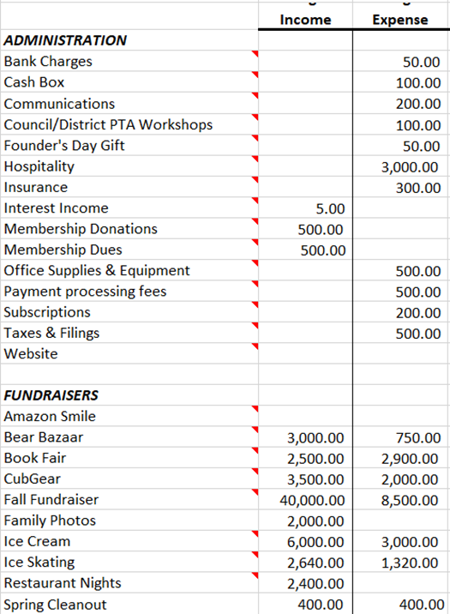

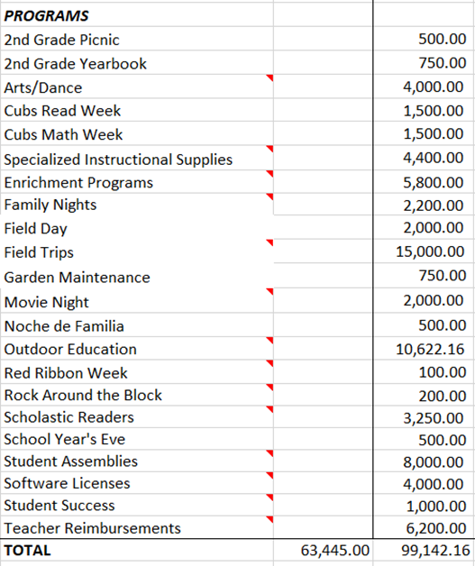

**· MOTION:** Ms. De Larme moved to adopt the budget as presented for the 2023-2024 school year. The motion was seconded by Harlisha Hamm and adopted by the PTA.

**·MOTION TO RELEASE MONIES:** Ms. De Larme moved to release the following monies totaling $29,400:

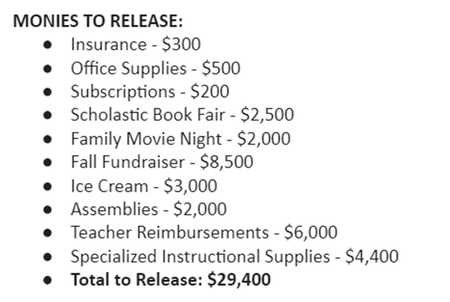

The motion was seconded by Corrine Rosensten and adopted by the PTA.

**·MOTION TO RATIFY CHECKS:** Ms. De Larme moved to ratify checks 4229 to 4237 dated 7/12/23 thru 9/8/23. The motion was seconded by Claudia Gonzalez and adopted.

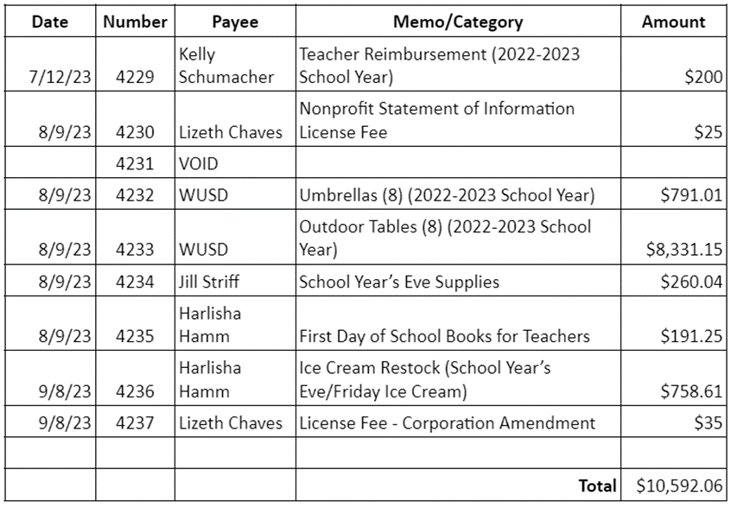

* Claudia Gonzalez mentioned how to join the pta by paying $10 a year. She mentioned the volunteer opportunities that are found on the website.

**Wiseburn Education Foundation (WEF):**

Erin Keller talked about how WEF raises funds to support programs throughout the district (music & arts education, teacher innovation grants, STEM education, robotics program, healthy lifestyle and wellness programs) WEF shared QR code to make a donation and mentioned the upcoming fundraiser on 9/20 for adults only for a Legos building competition.

She mentioned Rock around the block coming on May 4th, 2024.

* Jill Striff shared the website to find more information about the school and thanked the parents for attending the meeting.

**Next Meeting:**

Monday, October 2nd @ 5:59pm zoom

**Adjournment:** The meeting was adjourned at 6:01pm.

Lizeth Chaves

Recording Secretary

_____________________________ _______________________________

Date adopted as printed Date adopted as corrected